1. Create a SSRS report that show interactive sorting

Ans:

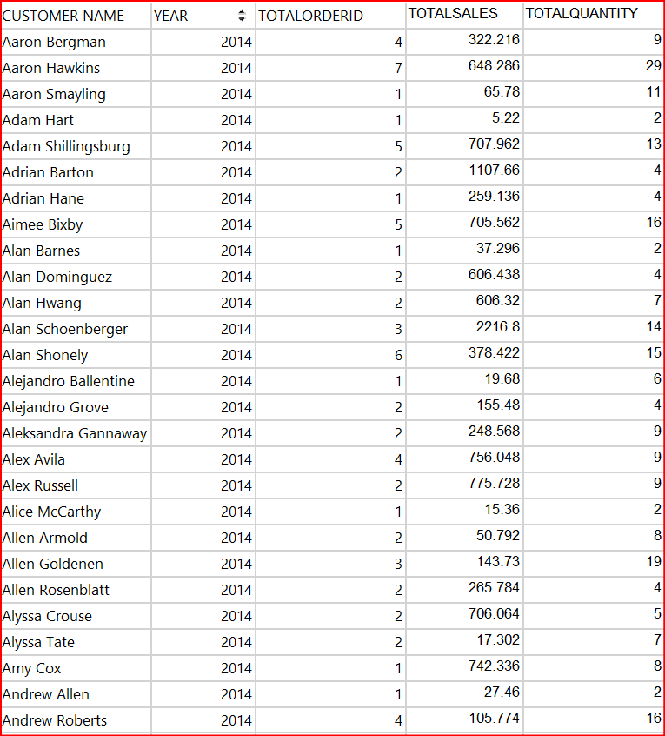

2 .Create a SSRS report that show conditional formatting

Ans:

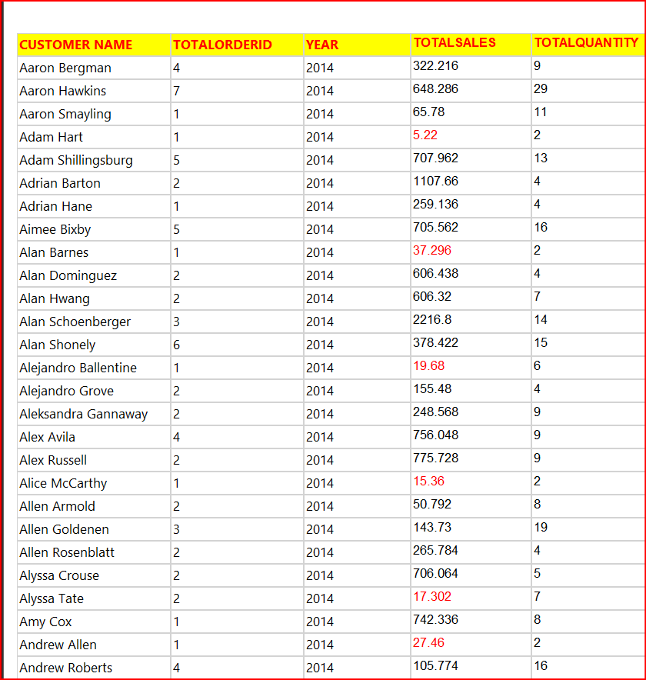

1. Create a SSRS report that show cascading parameter for below   
     country -> state -> city

Ans:

